Practical: 04
Aim: Use npm / yarn / pip to install and manage packages
Code:
C:\Users\mahes>node -v
v24.14.0

C:\Users\mahes>npm -v
11.9.0

C:\Users\mahes>mkdir npm-lab
A subdirectory or file npm-lab already exists.

C:\Users\mahes>cd m
The system cannot find the path specified.

C:\Users\mahes>cd npm-lab

C:\Users\mahes\npm-lab>npm init -y
Wrote to C:\Users\mahes\npm-lab\package.json:

{
"name": "npm-lab",
"version": "1.0.0",
"description": "",
"main": "index.js",
"scripts": {
"start": "node index.js",
"dev": "nodemon index.js"
},
"keywords": [],
"author": "",
"license": "ISC",
"type": "commonjs",
"dependencies": {
"axios": "^1.13.6",
"express": "^5.2.1"
},
"devDependencies": {
"nodemon": "^3.1.14"
}
}

C:\Users\mahes\npm-lab>npm install express

up to date, audited 103 packages in 2s

29 packages are looking for funding
run `npm fund` for details

found 0 vulnerabilities

C:\Users\mahes\npm-lab>npm install express

up to date, audited 103 packages in 2s

29 packages are looking for funding
run `npm fund` for details

found 0 vulnerabilities

C:\Users\mahes\npm-lab>npm install axios

up to date, audited 103 packages in 2s

29 packages are looking for funding
run `npm fund` for details

found 0 vulnerabilities

C:\Users\mahes\npm-lab>npm install nodemon --save-dev

up to date, audited 103 packages in 2s

29 packages are looking for funding
run `npm fund` for details

found 0 vulnerabilities

C:\Users\mahes\npm-lab>npm list
npm-lab@1.0.0 C:\Users\mahes\npm-lab
+-- axios@1.13.6
+-- express@5.2.1
`-- nodemon@3.1.14

C:\Users\mahes\npm-lab>npm run
Lifecycle scripts included in npm-lab@1.0.0:
start
node index.js
available via `npm run`:
dev
nodemon index.js

C:\Users\mahes\npm-lab>npm run dev

> npm-lab@1.0.0 dev
> nodemon index.js

[nodemon] 3.1.14
[nodemon] to restart at any time, enter `rs`
[nodemon] watching path(s): *.*
[nodemon] watching extensions: js,mjs,cjs,json
[nodemon] starting `node index.js`
Server running at http://localhost:3000
[nodemon] restarting due to changes...
[nodemon] starting `node index.js`
Server running at http://localhost:3000
Terminate batch job (Y/N)? y

C:\Users\mahes\npm-lab>npm run start

> npm-lab@1.0.0 start
> node index.js

Server running at http://localhost:3000
Terminate batch job (Y/N)? y

C:\Users\mahes\npm-lab>npm run dev

> npm-lab@1.0.0 dev
> nodemon index.js

[nodemon] 3.1.14
[nodemon] to restart at any time, enter `rs`
[nodemon] watching path(s): *.*
[nodemon] watching extensions: js,mjs,cjs,json
[nodemon] starting `node index.js`
Server running at http://localhost:3000
Output:
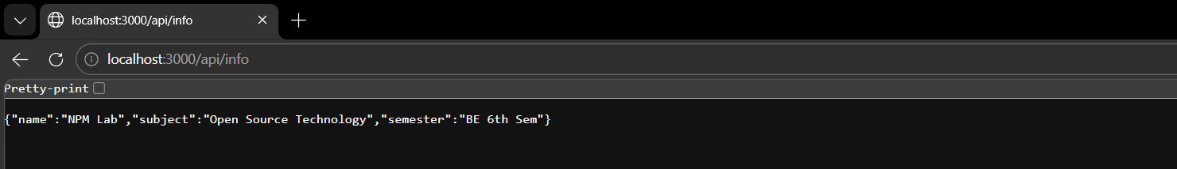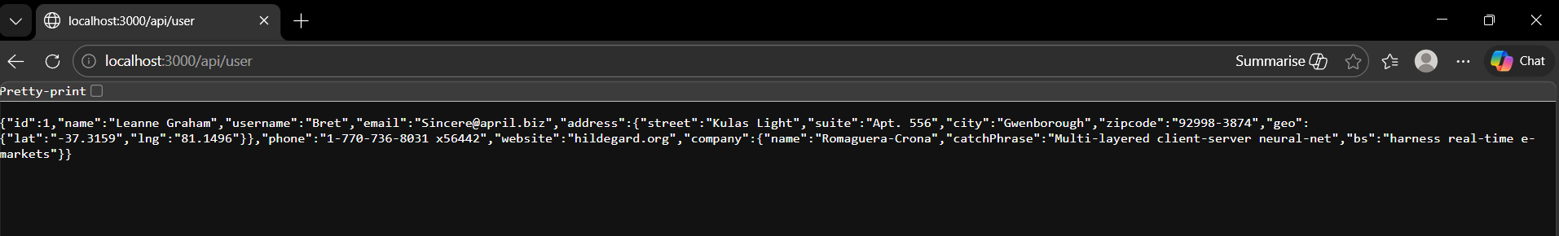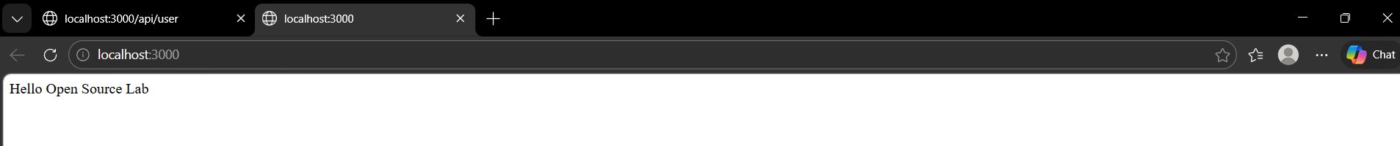
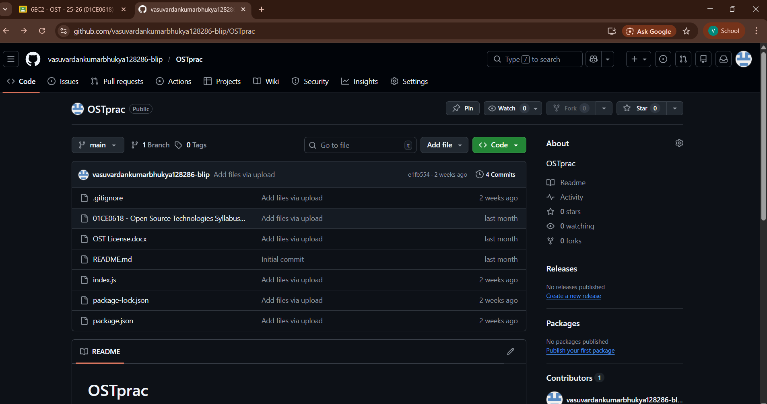

Practical: 05
Aim: Deploy a simple application using Nginx / Apache Code:
C:\Users\ mahes >cd C:\Users\gadhv\npm-lab
C:\Users\mahes\npm-lab>node index.js
Server running at http://localhost:3000
Nginx is runnnig
C:\Users\mahes>cd C:\nginx-1.28.2\nginx-1.28.2
C:\nginx-1.28.2\nginx-1.28.2>nginx -t
nginx: the configuration file C:\nginx-1.28.2\nginx-1.28.2/conf/nginx.conf syntax is ok
nginx: configuration file C:\nginx-1.28.2\nginx-1.28.2/conf/nginx.conf test is successful
C:\nginx-1.28.2\nginx-1.28.2>nginx
Output:
